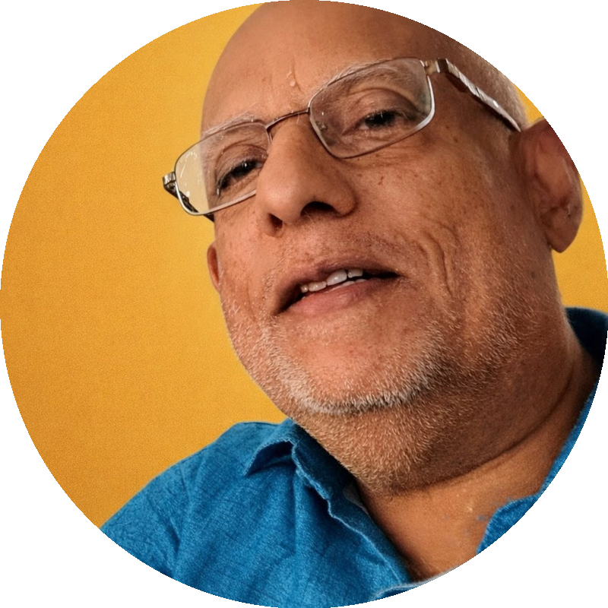

My profile photo
Name RATHINAVELU SACHIDANANDAM ,M.A (English)
My mobile number +whatsapp 919444318208
My email id srveli61@gmail.com
My youtube channel VELUGEETHA@ velugeethaofficial

https://rzp.io/rzp/dsBOwaK

https://rzp.io/rzp/XU07XOSu

https://rzp.io/rzp/kN64Ah4

https://rzp.io/rzp/TvtphVe1

https://rzp.io/rzp/Hev5IGE

https://rzp.io/rzp/6ilvwih

